SIMATS ENGINEERING (SAVEETHA SCHOOL OF ENGINEERING)
Department of Computer Science and Engineering
CO2 ASSESSMENT TOOL 1 – Scenario-Based Requirement Analysis

Course Code: | CSA1023 | Course Title: | Software Engineering
CO Assessed: | CO2 | Assessment: | Assessment Tool 2 – Scenario-Based Requirement Analysis
Weightage: | 20% | Total Marks: | 25
CO2 Statement: | Perform detailed requirements analysis, design scalable architectures, and prioritize features with a focus on cross-disciplinary skills
Student Name: | M. Meghana | Reg. No.: | 192472351
Date: | 21/10/2026 | Duration: | 60 minutes

Code of Conduct
I am M. MEGHANA - 192472351 certify that this submission is my original work and that I have adhered to the guidelines specified for this assessment. I understand that any violation of academic integrity rules will result in disciplinary action.
Signature of the Student: M. Meghana _________________________
Annexure A – Scenario-Based Requirement Analysis
Instructions to Students:
Each student will be assigned an individual software project problem statement. Analyze the given scenario and prepare a complete Software Requirement Analysis document by following the steps below.

Question
Based on the assigned problem statement, perform a Scenario-Based Requirement Analysis and prepare a Software Requirement Specification (SRS) document. Your analysis should include the following:
- Study and Analyze the Scenario
  - Carefully understand the given problem statement.
  - Identify the business domain, stakeholders, existing challenges, and system objectives.
- Identify Functional and Non-Functional Requirements
  - List all functional requirements required by the proposed system.
  - Identify suitable non-functional requirements such as performance, security, reliability, usability, scalability, maintainability, and availability.
- Identify Actors and Use Cases
  - Identify all primary and secondary actors interacting with the system.
  - List the major use cases associated with each actor.
  - Draw a Use Case Diagram representing the interactions between actors and the system.
- Prepare the Software Requirement Specification (SRS)
Develop an SRS document containing:
  - Introduction
  - Problem Description
  - Scope of the System
  - Functional Requirements
  - Non-Functional Requirements
  - Use Case Descriptions
  - Data Requirements
  - External Interface Requirements
  - System Features
- Identify Assumptions and Constraints
  - List the assumptions considered while developing the system.
  - Identify technical, operational, economic, legal, and time-related constraints affecting the project.
- Validate Requirement Completeness and Consistency
  - Verify whether all stakeholder requirements have been addressed.
  - Check for ambiguity, redundancy, inconsistency, and missing requirements.
  - Suggest improvements to enhance the quality and completeness of the requirement specification.
Answer:
1. Introduction
The Smart Disaster Response and Emergency Coordination Platform is a software system designed to manage emergencies such as floods, cyclones, earthquakes, and fires. It collects information from sensors, government agencies, rescue teams, and citizens to help authorities respond quickly.
The platform identifies the severity of incidents, assigns emergency teams, manages available resources, and displays real-time information through dashboards. It also uses a fault-tolerant architecture to maintain essential services during network interruptions.
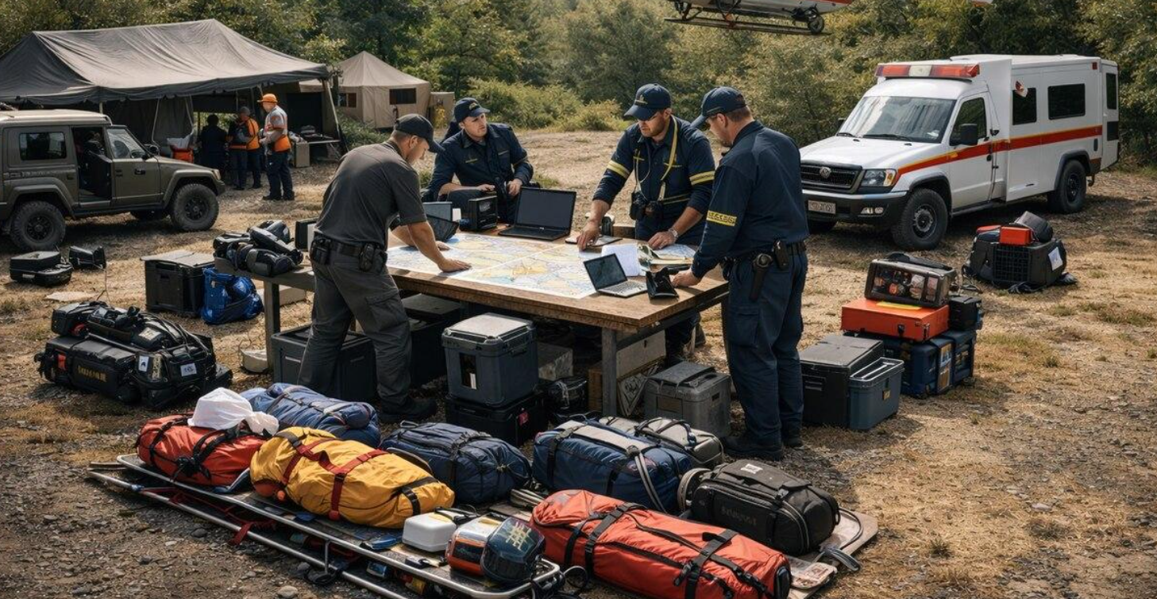
2. Scenario Understanding and Problem Analysis
Business domain: Disaster management, emergency services, public safety, and government administration.
Existing challenges:
- Emergency information comes from different sources and may be inconsistent.
- Delays in identifying critical incidents can cause loss of lives.
- Rescue teams and resources may not be allocated efficiently.
- Communication networks may fail during disasters.
- Manual coordination makes it difficult to monitor incidents in real time.
Proposed solution: Develop a centralized platform that collects emergency reports, prioritizes incidents, coordinates response teams, and provides real-time dashboards.
Objectives:
- Collect emergency information from multiple sources.
- Prioritize incidents based on severity.
- Assign rescue teams and resources efficiently.
- Display live incident information on dashboards.
- Maintain essential services during network failures.
- Protect sensitive emergency data.
3. Stakeholders
Stakeholders | Role
Disaster management authorities | Monitor incidents and make decisions.
Rescue teams | Respond to emergencies and update field status.
Medical teams | Provide medical assistance and transport patients.
Citizens | Report incidents and request emergency help.
Government agencies | Share warnings and emergency information.
System administrators | Manage users, security, monitoring, and system maintenance.

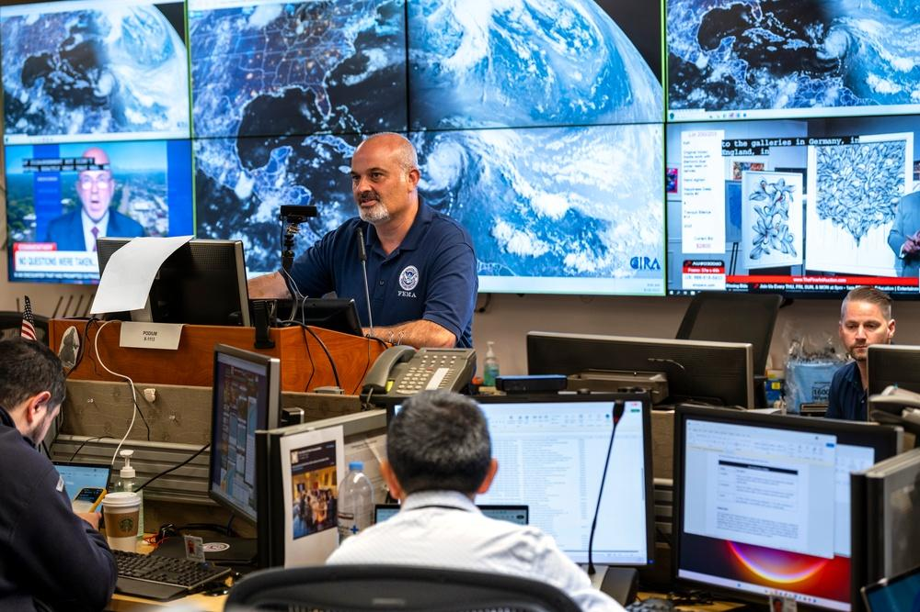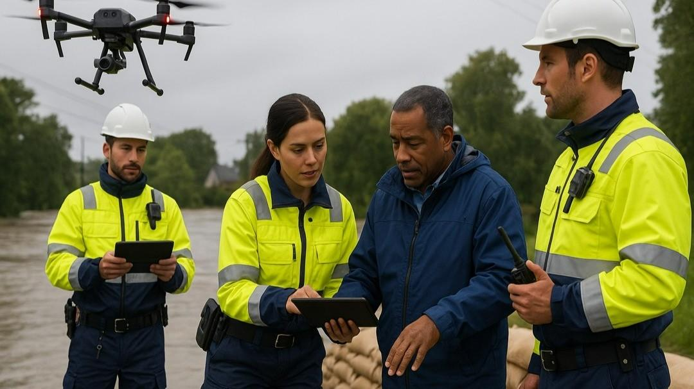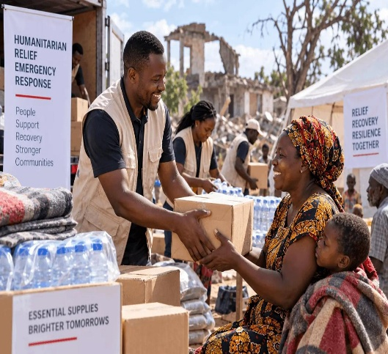
4. Functional Requirements
Functional requirements describe what the system must do.
- Incident reporting: Accept emergency reports from citizens, sensors, and agencies.
- Incident monitoring: Display incident location, type, time, and current status.
- Severity classification: Categorize incidents as Critical, High, Medium, or Low.
- Team allocation: Assign suitable rescue teams based on severity and availability.
- Resource management: Track ambulances, rescue vehicles, medical supplies, and other resources.
- Real-time dashboard: Display active incidents, team status, and resource availability.
- Notifications: Send alerts and updates to the relevant authorities and response teams.
- Communication: Allow authorized users to share incident updates.
- Offline support: Store essential updates locally during network interruptions and synchronize them when connectivity returns.
- User management: Provide secure login and role-based access.
- Reports: Generate incident summaries and response reports.
- Audit logging: Record important actions and system events.
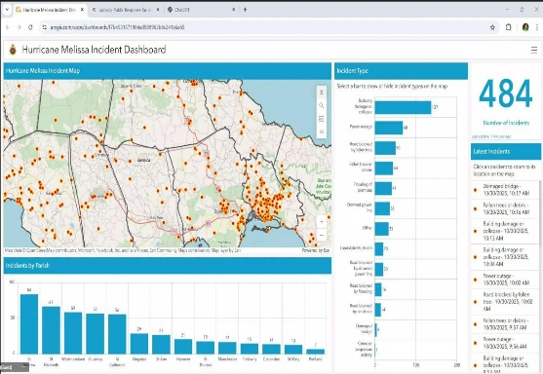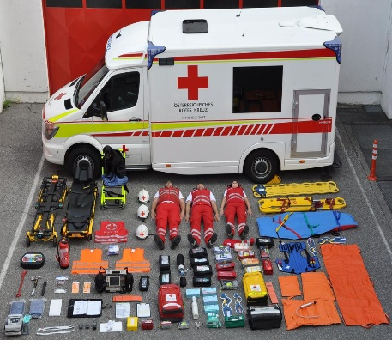

5. Non-Functional Requirements
Non-functional requirements describe the quality and performance expected from the system.
Requirement | Description
Performance | Process and display urgent reports with minimal delay.
Reliability | Process essential emergency operations consistently.
Availability | Keep critical services accessible during failures where possible.
Scalability | Support increasing incidents, users, and data volumes.
Security | Protect sensitive data using authentication, authorization, and encryption.
Usability | Provide a simple interface for officials and rescue teams.
Maintainability | Make the system easy to update and troubleshoot.
Fault tolerance | Continue essential operations when some components fail.
Interoperability | Exchange information through APIs with authorized external systems.
Recoverability | Restore services and synchronize stored updates after an interruption.
6. Actors and Use Cases
Actors are the people or external systems that interact with the platform.
Actor | Major use case
Citizen | Submit emergency reports and request help
Disaster management officer | Verify incidents, prioritize emergencies, assign teams, and monitor dashboards.
Rescue team | Receive assignments and update response status
Medical team | Receive medical requests and report patient assistance
Sensors and external agencies | Send alerts and incident data
System administrator | Manage users, permissions, logs, and system health.

Use Case Diagram
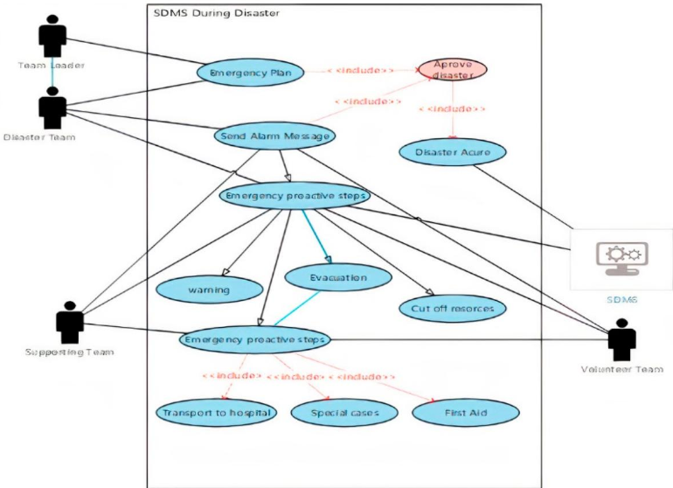
The diagram should show the Smart Disaster Response and Emergency Coordination Platform as a system boundary, with actors outside it and use cases inside it.
Main use cases to include:
- Report Emergency
- Verify Incident
- Classify Severity
- Assign Rescue Team
- Manage Resources
- Send Alerts
- Update Incident Status
- View Dashboard
- Generate Reports
- Manage Users

7. Software Requirement Specification (SRS)

7.1 Purpose
The purpose of the SRS is to define the functional and non-functional requirements of the disaster response platform. It provides a clear guide for developers, testers, administrators, and other stakeholders.

7.2 Scope of the System
The platform will provide a common interface for collecting incident information, assigning response teams, managing resources, and monitoring emergency operations.
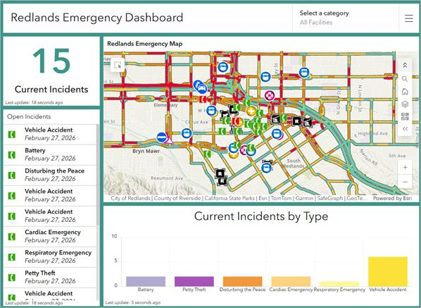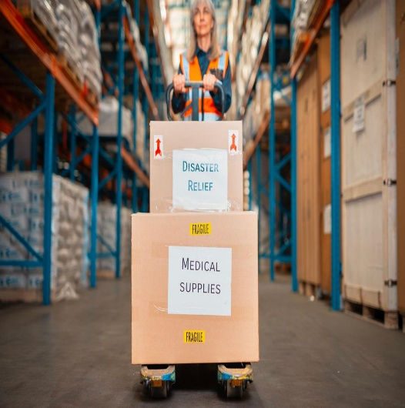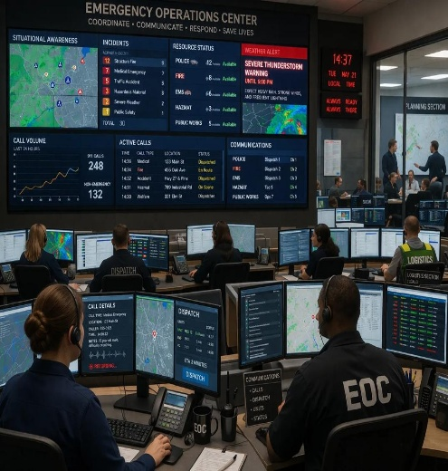
The system includes:
- Web-based operational dashboards.
- Incident reporting and severity classification.
- Rescue team and resource allocation.
- Notifications and status tracking.
- APIs for integration with external systems.
- Monitoring, logging, and fault recovery.
Out of scope: Physically conducting rescue operations, replacing emergency personnel, and guaranteeing communication when all networks are unavailable.
7.3 Use Case Descriptions
Use case | Description | Expected result
Report Emergency | A citizen or sensor submits an incident report. | Incident is recorded.
Prioritize Incident | An officer or system evaluates severity. | Incident receives a priority level.
Assign Team | An officer selects an available response team. | Team receives the assignment.
Send Notification | The system sends an alert about an emergency. | Relevant users receive the alert when communication is available.
Update Status | A rescue team reports progress. | Incident status is updated.
View Dashboard | An authorized officer opens the dashboard. | Current incidents and resource status are displayed.
7.4 Data Requirements
The system should store the following information:
Data entity | Important fields
Incident | Incident ID, type, location, time, severity, status
User | User ID, role, contact information, permissions
Response team | Team ID, team type, availability, location
Resource | Resource ID, category, quantity, availability
Notification | Notification ID, recipient, message, time, delivery status
Audit log | Event ID, user or service, action, timestamp, result
The database must protect sensitive information, maintain data consistency, and support recovery and synchronization after network interruptions.
7.5 External Interface Requirements
- User interface: A web dashboard for authorities and a simple reporting interface for citizens.
- Hardware interface: Support data from compatible sensors and field devices.
- Software interface: APIs for authorized agencies, mapping services, and notification services.
- Communication interface: Secure network communication and event-based messaging between system components.
7.6 System Features
- Incident management: Collect, verify, classify, and track incidents from multiple sources.
- Response coordination: Assign available rescue teams, ambulances, and other resources according to incident severity and availability.
- Real-time monitoring: Display active incidents, team movements, response status, and resource availability.
- Fault-tolerant services: Use APIs, event queues, containerization, monitoring, and automated recovery to maintain essential services when individual components fail.

8. System Architecture
The platform uses a distributed architecture so that different services can operate independently and communicate through APIs and event-driven messaging.
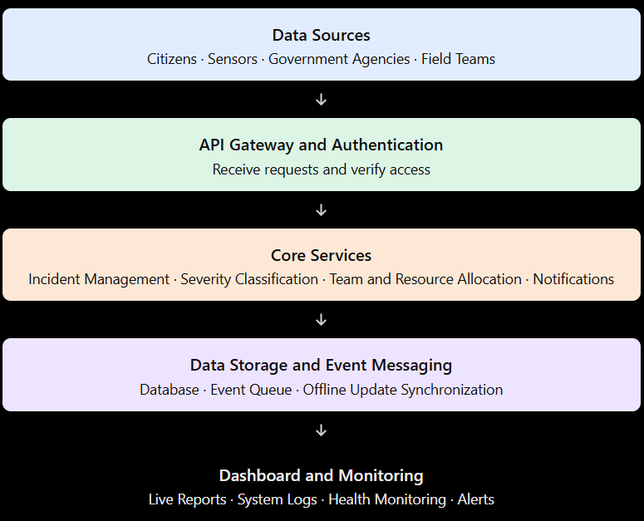

9. Assumptions and Constraints
Assumptions
- Citizens and authorized agencies can submit incident information.
- Rescue teams update their availability and response status.
- Authorities have permission to access emergency dashboards.
- External data sources provide information in supported formats.
- At least one communication channel may remain available during partial network failures.
Constraints
- Technical: Limited network connectivity, hardware failures, and integration difficulties.
- Operational: Rescue teams may be unavailable or unable to send updates.
- Economic: Budget limits may restrict servers, devices, and infrastructure.
- Security and legal: Personal and emergency data must be handled according to applicable privacy and security requirements.
- Time: Development and testing must be completed within the allocated project period.

10. Conclusion
The Smart Disaster Response and Emergency Coordination Platform provides a centralized and reliable approach to disaster management. It collects information from multiple sources, prioritizes emergencies, coordinates rescue teams, and monitors resources through real-time dashboards. By using scalable APIs, event-driven communication, containerization, automated deployment, monitoring, and logging, the platform can improve coordination and maintain essential services during partial failures. It can help authorities make faster, better-informed decisions and improve the effectiveness of disaster response operations.
Rubrics for Calculation
Criteria | Excellent (4 Marks) | Good (3 Marks) | Satisfactory (2 Marks) | Needs Improvement (1 Mark)
Scenario Understanding and Problem Analysis (30%) | Demonstrates thorough understanding of the scenario, stakeholders, objectives, and business context with clear analysis. | Demonstrates good understanding with minor omissions. | Basic understanding with limited analysis. | Poor understanding; major aspects missing or incorrect.
Functional and Non-Functional Requirement Identification (25%) | Clearly identifies comprehensive, accurate, and well-classified functional and non-functional requirements. | Identifies most requirements with minor classification errors. | Identifies only basic requirements; several omissions. | Requirements are incomplete, inaccurate, or poorly classified.
Actor Identification and Use Case Modelling (20%) | Correctly identifies all relevant actors and use cases; use case diagram is complete, accurate, and follows UML standards. | Most actors and use cases identified; diagram has minor errors. | Limited actors/use cases identified; diagram partially correct. | Actors/use cases missing or incorrect; diagram absent or inaccurate.
Software Requirement Specification (SRS) Documentation (15%) | SRS is well-structured, complete, professionally organized, and includes all required sections. | SRS is organized with minor missing sections or formatting issues. | SRS includes only essential sections with limited detail. | SRS is incomplete, poorly organized, or lacks essential components.
Assumptions, Constraints, and Requirement Validation (10%) | Clearly identifies realistic assumptions and constraints; validates requirements for completeness, consistency, and ambiguity with appropriate justification. | Identifies most assumptions and constraints; validation is adequate. | Limited assumptions/constraints; validation is superficial. | Assumptions, constraints, and validation are missing or incorrect.

Criteria | Mark
Scenario Understanding and Problem Analysis (30%) | /5
Functional and Non-Functional Requirement Identification (25%) | /5
Actor Identification and Use Case Modelling (20%) | /5
Software Requirement Specification (SRS) Documentation (15%) | /5
Assumptions, Constraints, and Requirement Validation (10%) | /5
TOTAL | /25

